Business Requirements Document
Plan Media

Author | Rahul Tiwari
Company
Created | 2023-12-03

Version | Date | Author | Description
1 | 12-03-2023 | Rahul Tiwari | Initial version for HRDB database for Plan Media
2 | 12-03-2023 | Rahul Tiwari | Added the table structure and constraint details

Table of Contents

1 Introduction 3
2 Source data 5
3 Detailed Mapping Tables 5
3.1 Employees Table 5
3.2 Departments Table 7
3.3 Locations Table 7
3.4 Countries Table 8
3.5 Regions Table 8
3.6 Jobs Table 9
3.7 Job History Table 9
4 Table Structure and constraints 10
4.1 Staging Layer 10
4.2 Transformation Layer 11
4.3 Final Layer 11
5 Business requirement 14
5.1 Data warehouse development 14
5.2 Tableau reporting solution 14

Introduction
Plan Media has grown big over the period of time and the human resource management needs a data warehouse to maintain huge amount of data and also needs a data analysis solution for quick action and informed decision making. In this project we need to create the entire end to end data warehouse and reporting solution for the business. The entire project will be going in the agile methodology and we will have to complete the entire project in 4 iterations. This document as of now consists of all the information we will be needing for the 1st iteration of the project.
Source Data Model
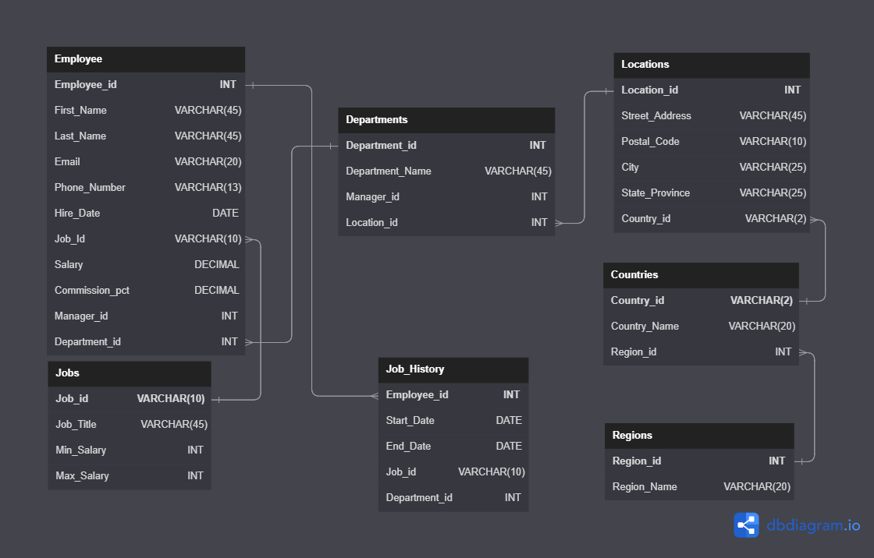

Source data
As of now business is storing all the data in the text files and have total 7 files in which they have all the dataset. Below are the file names and the information about what type of data is stored in those tables.

SRNO | File Name | Data details
1 | Employees.csv | All the employees related information
2 | Departments.csv | All the department related information
3 | Locations.csv | All the location related information
4 | Countries.csv | All the countries related information
5 | Regions.csv | All the regions related information
6 | Jobs.csv | All the jobs related information
7 | Job_History.csv | All the employee promotions related information

Detailed Mapping Tables
The tables below contain the detailed requirements for HRDB project. The Source HRDB Requirement consists of all the target columns and HRDB source data consists of all the source columns. Detailed source to target mapping consists of the logic which we need to apply on the columns. Those columns mentioned in the HRDB Requirements will only go to the final table.

Employees Table
HRDB Requirement | Detailed Source to Target Mapping | HRDB Source Data
EmployeeID | Direct Mapping  Nulls should not be there as it’s a primary key  Any issues report to the business | EmployeeID
Employee_Name | Concatenation of First_Name and the Last_Name  Cannot be null | First_Name
Employee_Name | Concatenation of First_Name and the Last_Name  Cannot be null | Last_Name
Email | Add the domain name in each of the email id  For example: Steven King email id should be sking@planmedia.com, we need this for all the employees  Email ID cannot be duplicate.  Cannot be null | Email
Phone_Number | Direct mapping  Cannot be null | Phone_Number
Hire_Date | Direct mapping  Cannot be null | Hire_Date
Job_ID | Direct mapping  Cannot be null | Job_Id
Salary | Direct mapping  There should not be any negative or 0 salary. Check this before insertion.  Cannot be null | Salary
Commission_PCT | If null make it 0 else keep the value as is | Commission_PCT
Monthly_Salary | Salary + (salary * commission_pct)  Cannot be null
Salary_Category | If salary >=2000 and salary <=6000 then “Low Salary”  If salary >6000 and salary <=10000 then “Average Salary”  If salary >10000 and salary <=15000 then “High Salary”  If salary >15000+ then “Very high salary”  Cannot be null | Salary
Manager_ID | Direct mapping | Manager_Id
Department_ID | Direct mapping  If no department assigned make the entry as 1000 as default | Department_Id

Departments Table
HRDB Requirement | Detailed Source to Target Mapping | HRDB Source Data
Department_Id | Direct Mapping  Nulls should not be there as it’s a primary key  Any issues report to the business  Add a new department 1000 | Department_Id
Department_Name | Direct Mapping  Add the new department as “Bench” with department id 1000  Cannot be null | Department_Name
Manager_Id | If manager_id is null make employee_id 100 as manager | Manager_Id
Location_id | Direct mapping | Location_id

Locations Table
HRDB Requirement | Detailed Source to Target Mapping | HRDB Source Data
Location_Id | Direct Mapping  Nulls should not be there as it’s a primary key  Any issues report to the business | Location_Id
Street_Address | Direct Mapping  Keep Nulls as is | Street_Address
Postal_Code | Direct Mapping  Keep Nulls as is | Postal_Code
City | Direct Mapping  Keep Nulls as is | City
State | Make Roma to Rome, State should be Lazio  Venice state should be Veneto  Hiroshima state as Hiroshima  Beijing state as Beijing  Bombay needs to be updated to Mumbai  Singapore State should be Singapore  London State should be England  Oxford State should be England | State_Province
Country_Id | Direct Mapping  Keep Nulls as is | Country_ID

Countries Table
HRDB Requirement | Detailed Source to Target Mapping | HRDB Source Data
Country_Id | Direct Mapping  Nulls should not be there as it’s a primary key  Any issues report to the business | Country_Id
Country | Direct Mapping  Keep Nulls as is | Country_Name
Region_Id | Direct Mapping  Keep Nulls as is | Region_Id

Regions Table
HRDB Requirement | Detailed Source to Target Mapping | HRDB Source Data
Region_Id | Direct Mapping  Nulls should not be there as it’s a primary key  Any issues report to the business | Region_Id
Region_Name | Direct Mapping  Keep Nulls as is | Region_Name
Region | If region_id = 3 then “APAC”  If region_id in (1, 4) then “EMEA”  If country is Brazil, Argentina and Mexico then “Latam”  If country is USA and Canada then “Noram”  For Australia we need to show as Oceania

Jobs Table
HRDB Requirement | Detailed Source to Target Mapping | HRDB Source Data
Job_Id | Direct Mapping  Nulls should not be there as it’s a primary key  Any issues report to the business | Job_Id
Job_Title | Direct Mapping | Job_Title
Min_Salary | Direct Mapping | Min_Salary
Max_Salary | Direct Mapping | Max_Salary

Job History Table
HRDB Requirement | Detailed Source to Target Mapping | HRDB Source Data
Employee_Id | Direct Mapping  Nulls should not be there as it’s a primary key  Any issues report to the business | Employee_Id
Start_Date | Direct Mapping | Start_Date
End_Date | Direct Mapping | End_Date
Job_Id | Direct Mapping | Job_Id
Department_Id | Direct Mapping | Department_Id

Table Structure and constraints

Staging Layer

The table names we wanted to finalize as the naming convention as TBL_STG_XXXXXXXX, below are the table names, we don’t want to add any constraints in these tables
Table Names
TBL_STG_EMPLOYEES
TBL_STG_JOBS
TBL_STG_JOB_HISTORY
TBL_STG_COUNTRIES
TBL_STG_LOCATIONS
TBL_STG_DEPARTMENTS
TBL_STG_REGIONS

Transformation Layer
TBD

Final Layer

The table names we wanted to finalize as the naming convention as TBL_FNL_XXXXXXXX, below are the table names
Table Names
TBL_FNL_EMPLOYEES
TBL_FNL_JOBS
TBL_FNL_JOB_HISTORY
TBL_FNL_COUNTRIES
TBL_FNL_LOCATIONS
TBL_FNL_DEPARTMENTS
TBL_FNL_REGIONS

- Below are the constraints on each of the tables

TBL_FNL_EMPLOYEES

Table Name | TBL_FNL_EMPLOYEES
Columns | Datatype | Constraints
Employee_Id | INT | Primary Key
Employee_Name | VARCHAR(50) | Not Null
Email | VARCHAR(50) | Unique
Phone_Number | VARCHAR(15) | Unique
Hire_Date | DATE | Default (Current Date)
Job_Id | VARCHAR(10)
Salary | DECIMAL(10,2) | Check Salary > 0
Commission_PCT | DECIMAL(3,2)
Monthly_Salary | DECIMAL(15,2)
Salary_Category | VARCHAR(20)
Manager_ID | INT | Foreign Key Referencing Employee_Id in TBL_FNL_EMPLOYEES
Department_ID | INT | Foreign Key Referencing Department_ID in TBL_FNL_DEPARTMENTS

TBL_FNL_DEPARTMENTS
Table Name | TBL_FNL_DEPARTMENTS
Columns | Datatype | Constraints
Department_Id | INT | Primary Key
Department_Name | VARCHAR(50) | Not Null
Manager_Id | INT | Foreign Key Referencing Employee_Id in TBL_FNL_EMPLOYEES
Location_Id | INT | Foreign Key Referencing Location_Id in TBL_FNL_LOCATIONS

TBL_FNL_LOCATIONS
Table Name | TBL_FNL_LOCATIONS
Columns | Datatype | Constraints
Location_Id | INT | Primary Key
Street_Address | VARCHAR(50) | Not Null
Postal_Code | INT
City | VARCHAR(25)
State_Province | VARCHAR(25)
Country_Id | VARCHAR(2) | Foreign Key Referencing Country_Id in TBL_FNL_COUNTRIES

TBL_FNL_COUNTRIES
Table Name | TBL_FNL_COUNTRIES
Columns | Datatype | Constraints
Country_Id | VARCHAR(2) | Primary Key
Country_Name | VARCHAR(20) | Not Null
Region_Id | INT | Foreign Key Referencing Region_Id in TBL_FNL_REGIONS

TBL_FNL_REGIONS
Table Name | TBL_FNL_REGIONS
Columns | Datatype | Constraints
Region_Id | INT | Primary Key
Region_Name | VARCHAR(50) | Not Null
Region | VARCHAR(50) | Not Null

TBL_FNL_JOBS
Table Name | TBL_FNL_JOBS
Columns | Datatype | Constraints
Job_Id | VARCHAR(10) | Primary Key
Job_Title | VARCHAR(50) | Not Null
Min_Salary | DECIMAL(10,2) | Check Min_Salary > 0
Max_Salary | DECIMAL(10,2) | Check Max_Salary > 0

TBL_FNL_JOB_HISTORY
Table Name | TBL_FNL_JOB_HISTORY
Columns | Datatype | Constraints
Employee_Id | INT | Foreign Key Referencing Employee_Id in TBL_FNL_EMPLOYEES
Start_Date | DATE
End_Date | DATE
Job_ID | VARCHAR(10) | Foreign Key Referencing Job_Id in TBL_FNL_JOBS
Department_ID | INT | Foreign Key Referencing Department_Id in TBL_FNL_DEPARTMENTS

Business requirement
The requirement is to build the data warehouse and the reporting solution so that we can take the quick and informed decisions.

Data warehouse development
We are planning to use MySQL as the database and need to create the entire data warehouse in that database.
Suggestions are welcome how the development will be end to end

Tableau reporting solution
We need to create the user specific dashboards and below is the list of dashboards which we need
- Executive Dashboard
- Department Level Dashboard
- Employee Level Dashboard

We don’t have any specific design in our mind, we need the development team to design and give us the best interactive solution

